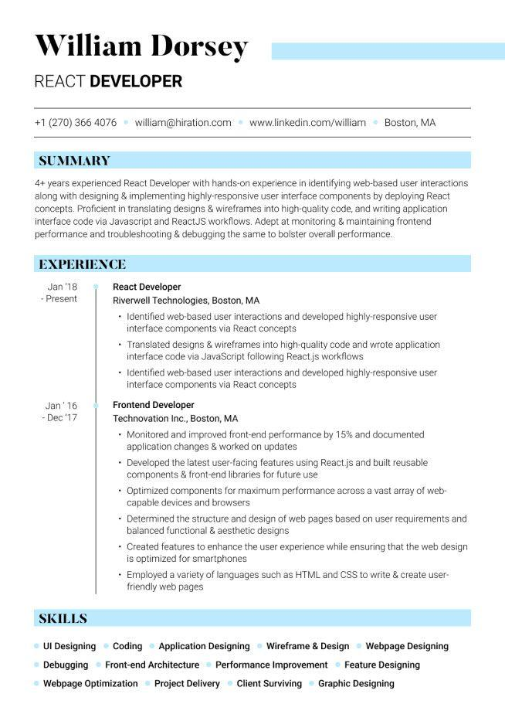
William Dorsey
REACT DEVELOPER
+1 (270) 366 4076 william@hiration.com www.linkedin.com/william Boston, MA
SUMMARY
4+ years experienced React Developer with hands-on experience in identifying web-based user interactions along with designing & implementing highly-responsive user interface components by deploying React concepts. Proficient in translating designs & wireframes into high-quality code, and writing application interface code via Javascript and ReactJS workflows. Adept at monitoring & maintaining frontend performance and troubleshooting & debugging the same to bolster overall performance.
EXPERIENCE
Jan '18 - Present
Jan'16
- Dec '17
React Developer
Riverwell Technologies, Boston, MA
• Identified web-based user interactions and developed highly-responsive user interface components via React concepts
• Translated designs & wireframes into high-quality code and wrote application interface code via JavaScript following React.js workflows
• Identified web-based user interactions and developed highly-responsive user interface components via React concepts
Frontend Developer
Technovation Inc., Boston, MA
• Monitored and improved front-end performance by 15% and documented application changes & worked on updates
• Developed the latest user-facing features using React.js and built reusable components & front-end libraries for future use
• Optimized components for maximum performance across a vast array of web- capable devices and browsers
• Determined the structure and design of web pages based on user requirements and balanced functional & aesthetic designs
• Created features to enhance the user experience while ensuring that the web design is optimized for smartphones
• Employed a variety of languages such as HTML and CSS to write & create user- friendly web pages
SKILLS
Application Designing Wireframe & Design
Webpage Designing
Debugging Front-end Architecture Performance Improvement Feature Designing
UI Designing⚫ Coding
Webpage Optimization
Project Delivery ⚫ Client Surviving Graphic Designing

